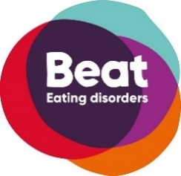
Beat Echo Peer Coach Volunteer Application form
Are you passionate about supporting people?
Do you want to make a difference for people affected by eating disorders?
Are you looking to enhance your skills and empower people to get the support that they deserve?
As an Echo Peer coach, you will empower parent carers who are currently supporting someone through recovery. You will join a passionate team of staff and volunteers working towards ending the pain and suffering caused by eating disorders.

A full online training course (six 60-90 minute sessions) will give you all the essential skills.
Take the first step - apply now!

About You
First Name
Last Name
Email Address
Phone Number
Address
Postcode
Personal experience caring for someone with (as a sibling, parent or partner)
How long has the person you cared for been in recovery?

Please can you answer the following questions: think about the Echo Peer Coach role description to help you answer.

Why would you like to become an Echo Peer Coach
(500 words max)

What experiences do you have that make you suitable for this role
(500 words max)

If you are successful in your application, you will have a regular 30-minute phone call with your matched parent carer every week over 6 months. Could you please indicate your availability for this below:

 | 9-10am | 10-11am | 11-12pm | 12pm – 2pm | 2pm – 4pm | 4pm – 6pm | 6pm-8pm
Monday
Tuesday
Wednesday
Thursday
Friday
Saturday
Sunday

Please can you provide us with two references who can comment on your suitability for the volunteer role?
Reference 1:
Full Name
Email Address
Phone Number
Relation to you
i.e. Boss, friend
How long has this person known you

Reference 2:
Full Name
Email Address
Phone Number
Relation to you
i.e. Boss, friend
How long has this person known you

EQUAL OPPORTUNITIES MONITORING FORM  (Volunteer) |  |  | 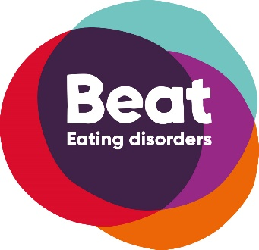
The information on this form will be treated in complete confidence.  We will use the information to monitor diversity. At no time will your details be seen outside of the HR Team or passed to any external organisation. Once the information has been recorded this document will be destroyed confidentially.  Consent: I agree to the information given below being electronically recorded by Beat for use only as described above.  (please tick if you agree) |  |  | Unit 1 Chalk Hill House  19 Rosary Road  Norwich  NR1 1SZ
Surname |  | Forenames
Gender |  | Date of birth
Sexual Orientation |  | Religion

Do you consider yourself to be a disabled person?
Please give details of the nature of any disability:
Please specify any adjustments required (e.g. access, speech amplifiers, etc):

Have you suffered with an eating disorder?
If yes, please state which eating disorder?
I would describe my ethnic origin as:
Black: | OAfrican | O Caribbean | O Other, please specify:
Asian: | O Indian | O Pakistani | O Other, please specify:
White: | O British | O European | O Other, please specify:
Chinese: | O Chinese |  | O Other, please specify:
To submit please forward to : admin@beateatingdisorders.org.uk

