EQUAL OPPORTUNITIES MONITORING FORM  (Volunteer) |  |  | 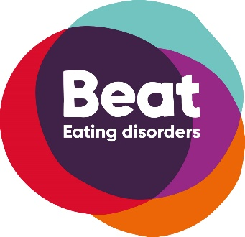
The information on this form will be treated in complete confidence.  We will use the information to monitor diversity. At no time will your details be seen outside of the HR Team or passed to any external organisation. Once the information has been recorded this document will be destroyed confidentially.  Consent: I agree to the information given below being electronically recorded by Beat for use only as described above.  (please tick if you agree) |  |  | Unit 1 Chalk Hill House  19 Rosary Road  Norwich  NR1 1SZ
Surname |  | Forenames
Gender |  | Date of birth
Sexual Orientation |  | Religion

Do you consider yourself to be a disabled person?
Please give details of the nature of any disability:
Please specify any adjustments required (e.g. access, speech amplifiers, etc):

Have you suffered with an eating disorder?
If yes, please state which eating disorder?
I would describe my ethnic origin as:
Black: | OAfrican | O Caribbean | O Other, please specify:
Asian: | O Indian | O Pakistani | O Other, please specify:
White: | O British | O European | O Other, please specify:
Chinese: | O Chinese |  | O Other, please specify:

